LAB Manual

**Experiment No.01**

PART B

| Roll No. C009 | Name: Samarth Borade |
| --- | --- |
| Class : BTI SEM 10 | Batch : B1 |
| Date of Experiment: 15/12/23 | Date of Submission |
| Grade : | Time of Submission: |
| Date of Grading: |  |

**B.1 Software Code written by student:**

**​​#Samarth Borade**

**#Roll No: C009**

**#BTI SEM 10**

**#Batch: B1**

**#Exp No: 1**

**#Aim: Implementation of Perceptron from scratch**

**# Modules used for data handling and linear algebra operations.**

**import pandas as pd**

**import numpy as np**

**# Modules used for data visualization**

**import matplotlib.pyplot as plt**

**import seaborn as sns**

**sns.set_style()**

**# Modules used for encoding the categorical variables.**

**from sklearn.preprocessing import OneHotEncoder**

**df = pd.read_csv("crx.csv",*header*=None)**

**df.head()**

**df.columns = df.iloc[0]**

**df = df[1:]**

**df.head()**

**df.info()**

**df.dtypes.value_counts().plot(*kind*="bar",*title*="Types of Data",*xlabel*="Data Type",*ylabel*="No.of columns",*rot*=0,*color*=["crimson","orange"])**

**plt.show()**

**cat_cols = []**

**num_cols = []**

**for i in df.columns:**

**if df[i].dtype == "O":**

**cat_cols.append(i)**

**else:**

**num_cols.append(i)**

**null_freq = []**

**for i in df.columns:**

**f = dict(df[i].value_counts())**

**if "?" in f.keys():**

**null_freq.append(f["?"]*100/len(df))**

**else:**

**null_freq.append(0)**

**pd.Series(dict(zip(df.columns,null_freq))).plot(*kind*="bar",*rot*=0,*title*="Missing Value Frequency",*xlabel*="Column Name",*ylabel*="Percentage of missing values",*color*=["orange","crimson"])**

**plt.show()**

**df['a16'].value_counts().plot(*kind*="bar",*title*="Class Distribution",*xlabel*="Status of Credit Card Approval",*ylabel*="Frequency of the Status",*color*=["crimson","orange"],**

***rot*=0)**

**plt.show()**

**df = df.replace({"?":None})**

**df = df.dropna()**

**numerical_columns = df.select_dtypes(*include*=['float64', 'int64']).columns**

**Q1 = df[numerical_columns].quantile(0.25)**

**Q3 = df[numerical_columns].quantile(0.75)**

**IQR = Q3 - Q1**

**threshold = 1.5**

**# Remove rows with values outside the acceptable range**

**df = df[~((df[numerical_columns] < (Q1 - threshold * IQR)) | (df[numerical_columns] > (Q3 + threshold * IQR))).any(*axis*=1)]**

**encoder = OneHotEncoder(*sparse*=False)**

**for i in cat_cols:**

**df[i] = encoder.fit_transform(df[i].values.reshape(-1,1))**

**from sklearn.model_selection import train_test_split**

**X_train,X_test,y_train,y_test = train_test_split(df,**

**df['a16'],**

***test_size* = 0.10,**

***train_size*=0.90,*random_state* = 0**

**)**

**X_train.pop('a16')**

**X_test.pop('a16')**

**class Perceptron:**

**# Initialising the required parameters for the perceptron.**

**def __init__(*self*, *X*, *y*, *learning_rate*, *epochs* : int):**

***self*.X = *X***

***self*.y = *y***

***self*.learning_rate = *learning_rate***

***self*.epochs = *epochs***

**# Activation function.**

**def __activation_function(*self*,*x*):**

**return 1.0 if (*x* > 0) else 0.0**

**# The model training or fitting by updating weights.**

**def fit(*self*):**

**n_rows,n_cols = *self*.X.shape**

***self*.weights = np.zeros((n_cols + 1, 1))**

**for epoch in range(*self*.epochs):**

**for index, features in enumerate(*self*.X.values):**

**feature_transposed = np.insert(features, 0, 1).reshape(-1,1)**

**predicted_target = *self*.__activation_function(np.dot(feature_transposed.T, *self*.weights))**

**flag = np.squeeze(predicted_target) - *self*.y[index]**

**if flag != 0:**

***self*.weights += *self*.learning_rate*((*self*.y[index] - predicted_target)*feature_transposed)**

**# Predicting on a single instance.**

**def predict(*self*, *X_test*):**

**return *self*.__activation_function(np.dot(p.weights.reshape(1,-1)[0],*X_test*))**

**# Predicting on a larger number of instances and returning accuracy.**

**def test(*self*, *test_data*, *y*):**

**x = []**

**for i in range(len(*test_data*.values)):**

**X_test = np.array(*test_data*.iloc[i])**

**x.append(p.predict(np.insert(X_test,0,1)) == p.y[i])**

**return sum(x)*100/len(*test_data*)**

**y = np.array(pd.DataFrame(y_train).reset_index().drop(["index"],*axis*=1))**

**X = pd.DataFrame(X_train).reset_index().drop(["index"],*axis*=1)**

**p = Perceptron(X, y, 0.5, 50)**

**p.fit()**

**p.test(pd.DataFrame(X_test).reset_index().drop(["index"],*axis*=1),**

**np.array(pd.DataFrame(y_test).reset_index().drop(["index"],*axis*=1)))**

**train_acc = []**

**test_acc = []**

**epochs = []**

**for i in range(20,200,20):**

**y = np.array(pd.DataFrame(y_train).reset_index().drop(["index"],*axis*=1))**

**X = pd.DataFrame(X_train).reset_index().drop(["index"],*axis*=1)**

**p = Perceptron(X, y, 0.5, i)**

**p.fit()**

**train_acc.append(p.test(X,y))**

**test_acc.append(p.test(pd.DataFrame(X_test).reset_index().drop(["index"],*axis*=1),**

**np.array(pd.DataFrame(y_test).reset_index().drop(["index"],*axis*=1))))**

**epochs.append(i)**

**plt.figure(*figsize*=(10,10))**

**plt.plot(epochs,train_acc)**

**plt.plot(epochs,test_acc)**

**plt.xlabel("Number of Epochs")**

**plt.ylabel("Accuracy of the model")**

**plt.legend(['Train Accuracy',"Test Accuracy"])**

**plt.show()**

**tuning = pd.DataFrame({"epochs":np.array(epochs).squeeze(),"train accuracy":np.array(train_acc).squeeze(), "test accuracy":np.array(test_acc).squeeze()})**

**def diff(*row*):**

**return *row*[1] - *row*[2]**

**tuning["Difference"] = tuning.apply(diff,*axis*=1)**

**tuning.sort_values(*by*="Difference")**

**For Dataset 2:**

# Cirrhosis Patient Survival Prediction

df = pd.read_csv("cirrhosis.csv",*header*=None)

from sklearn.model_selection import train_test_split

X_train,X_test,y_train,y_test = train_test_split(df,

df['Stage'],

*test_size* = 0.10,

*train_size*=0.90,

*random_state* = 0)

X_train.pop('Stage')

X_test.pop('Stage')

**B.2 Input and Output:**

**Input Dataset 1:**

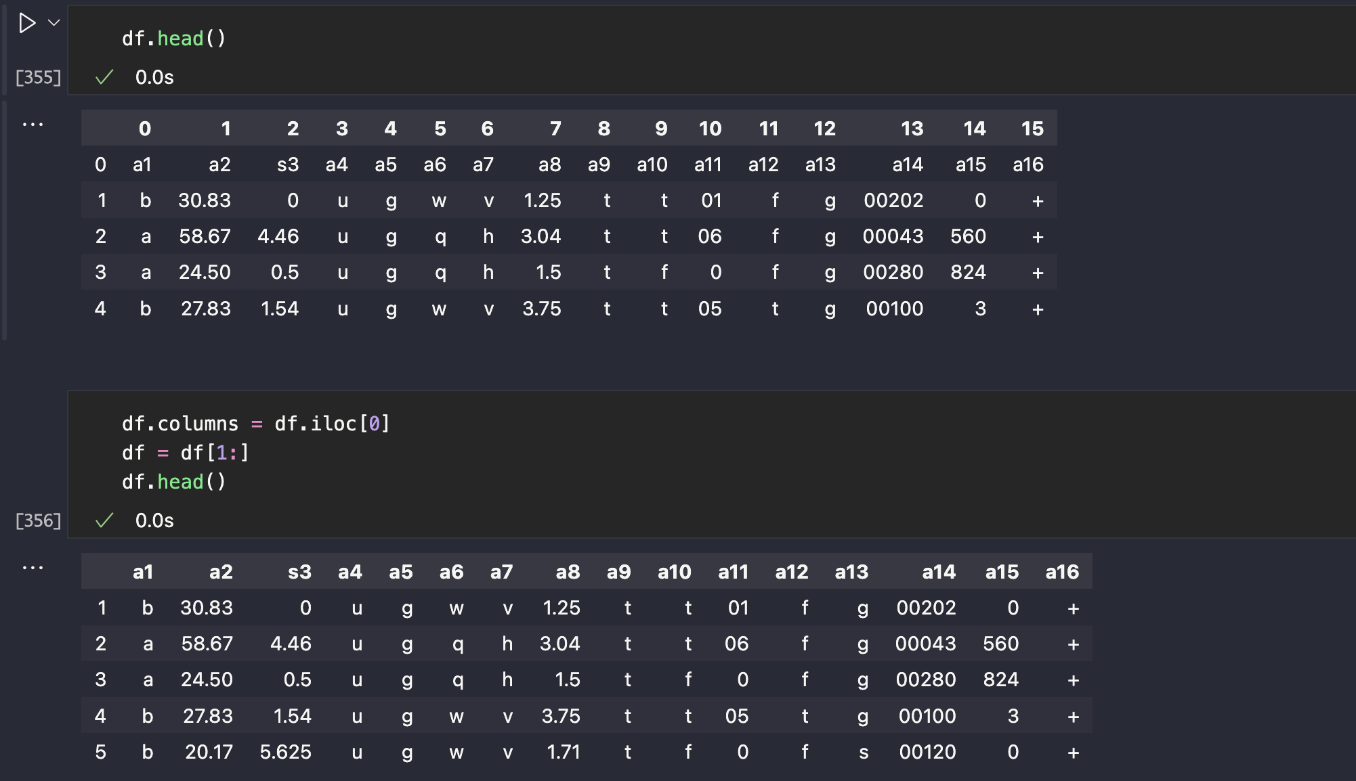

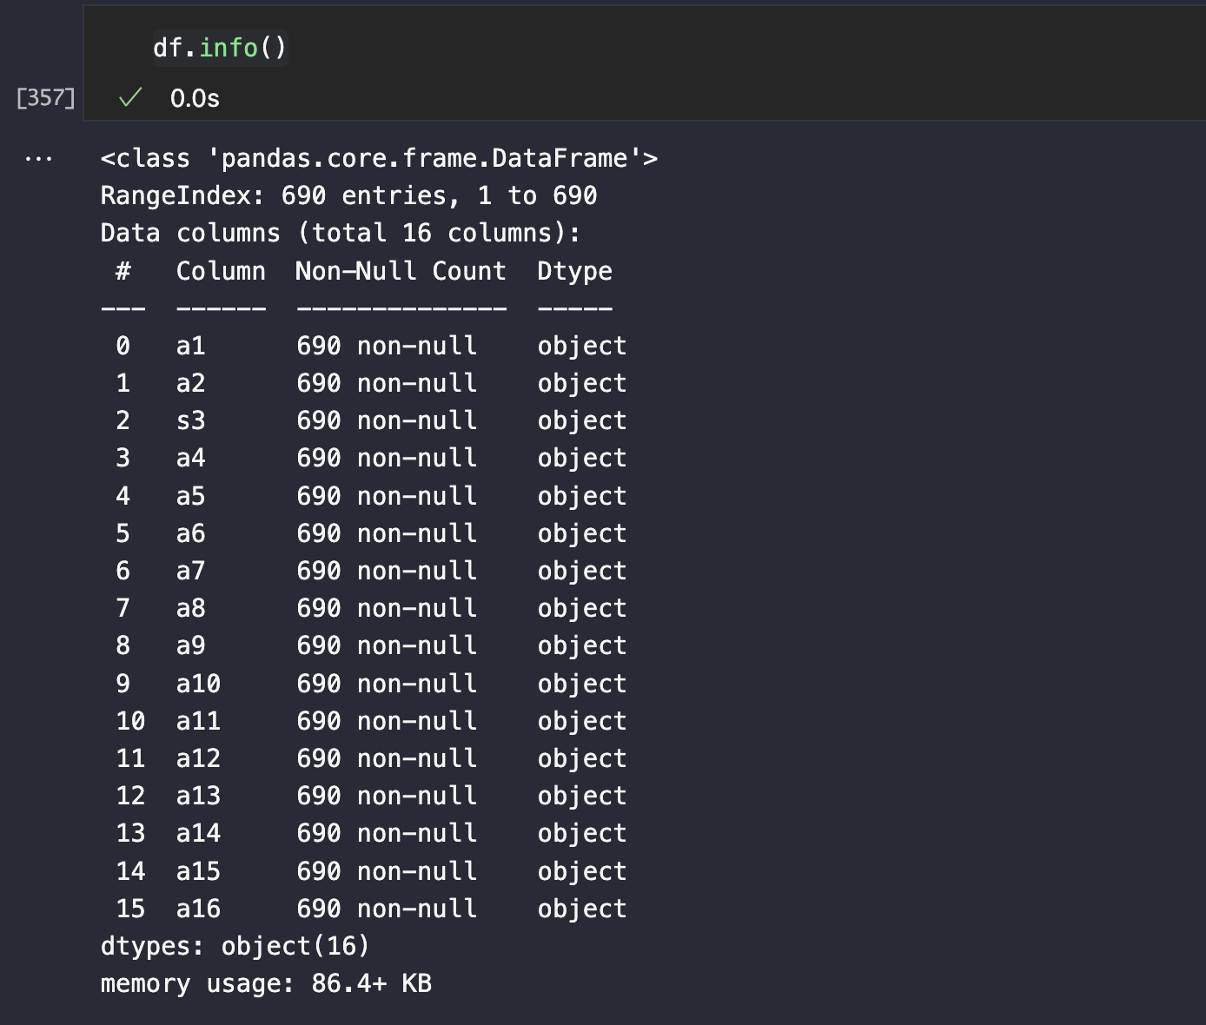

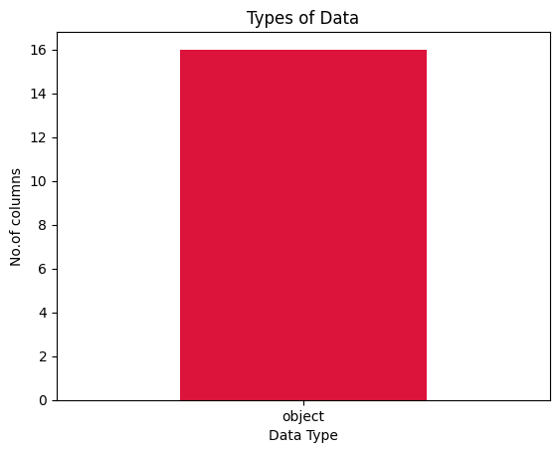

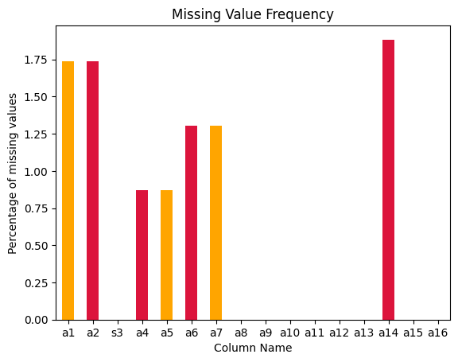

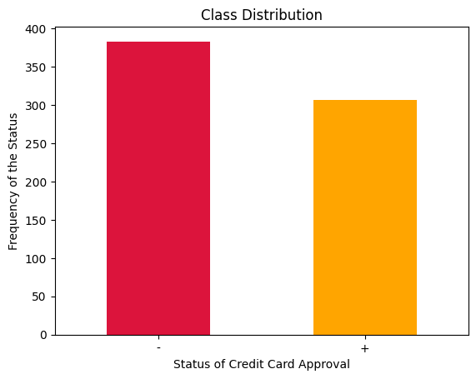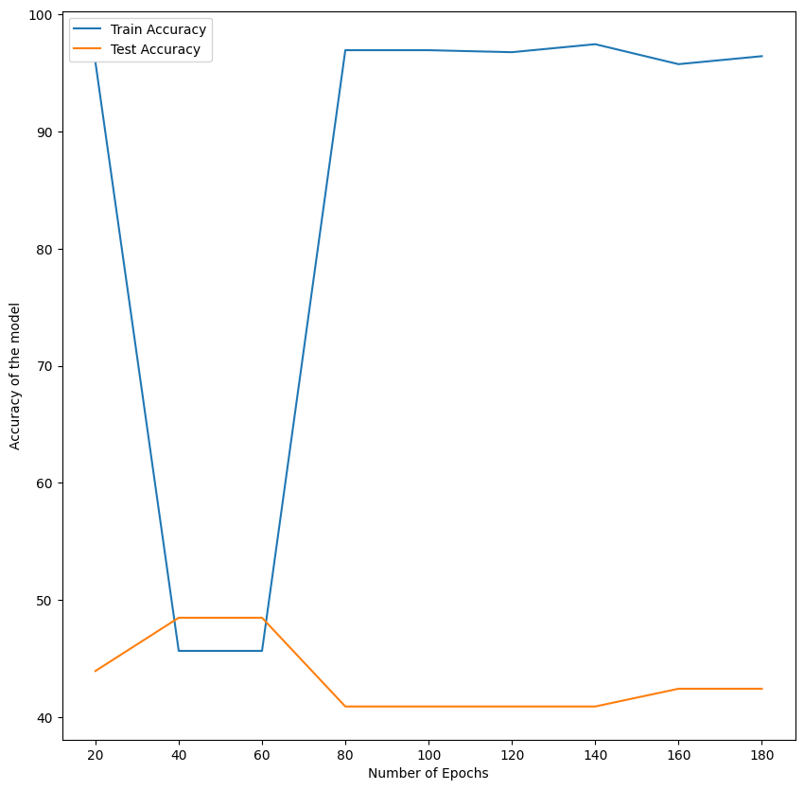

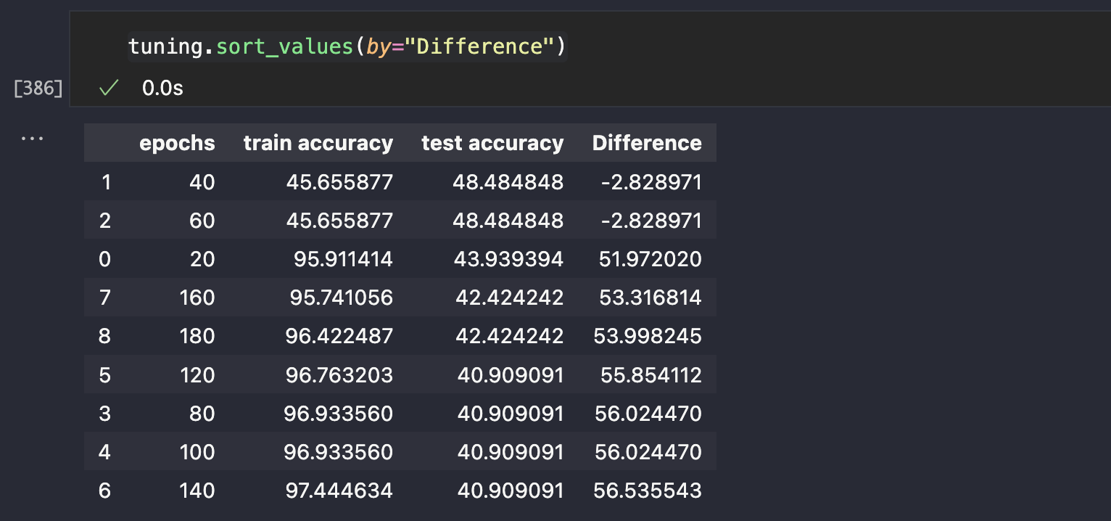

**Dataset 2:**

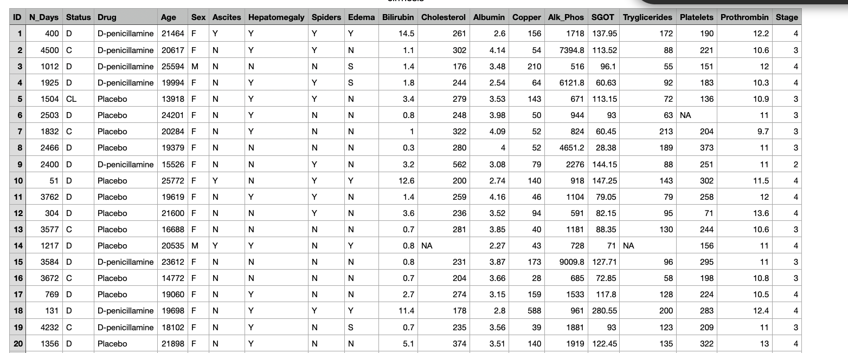

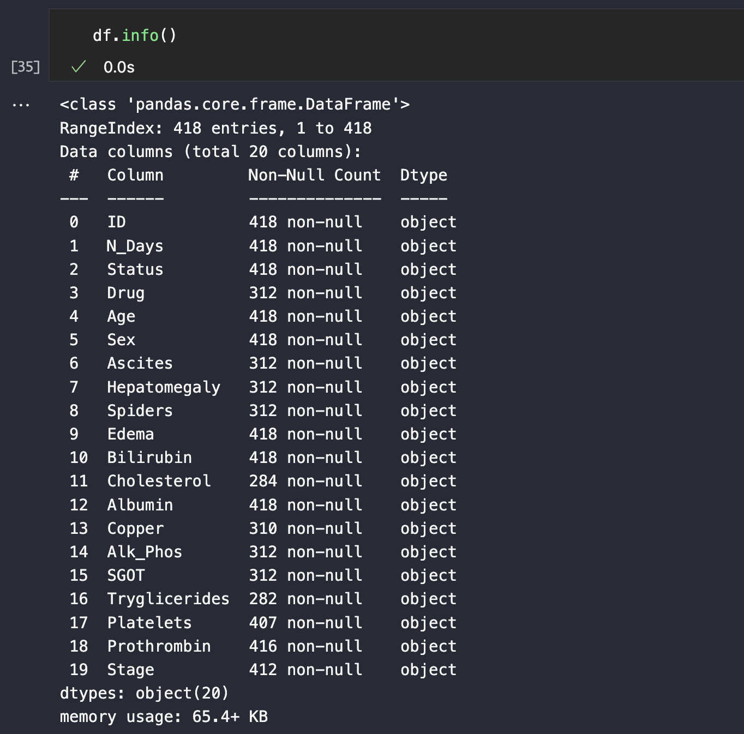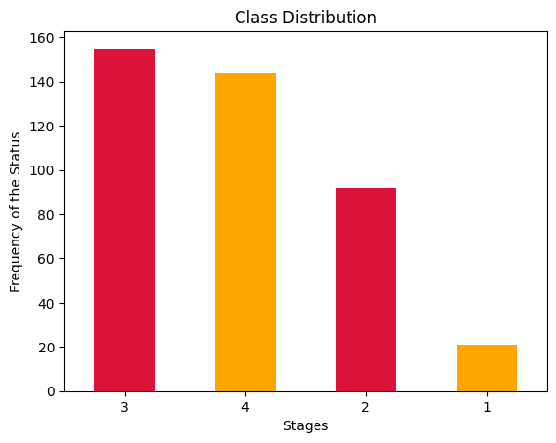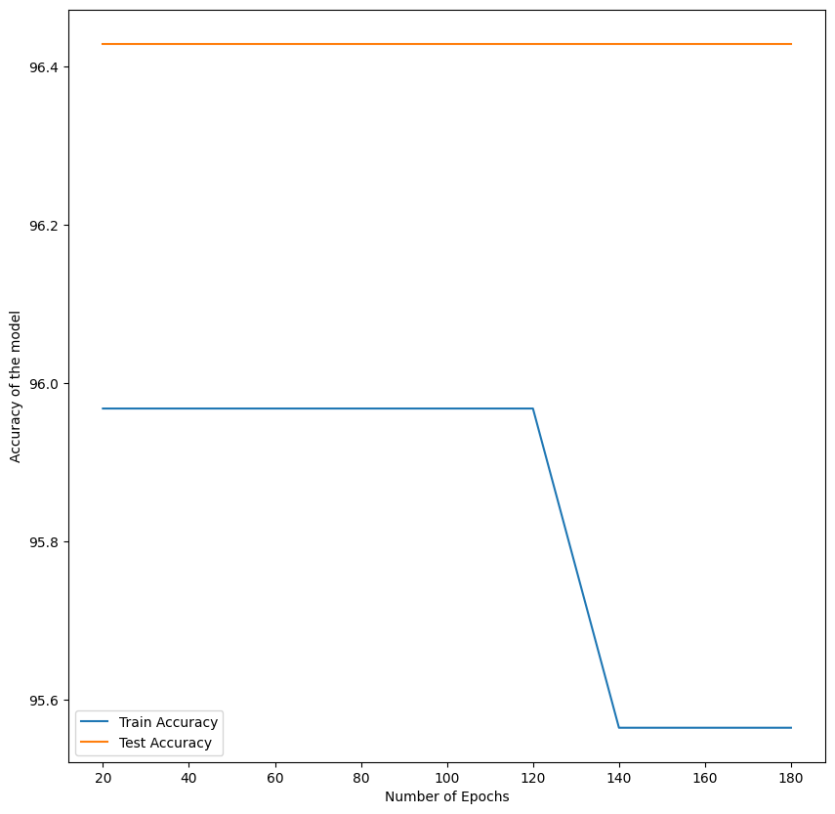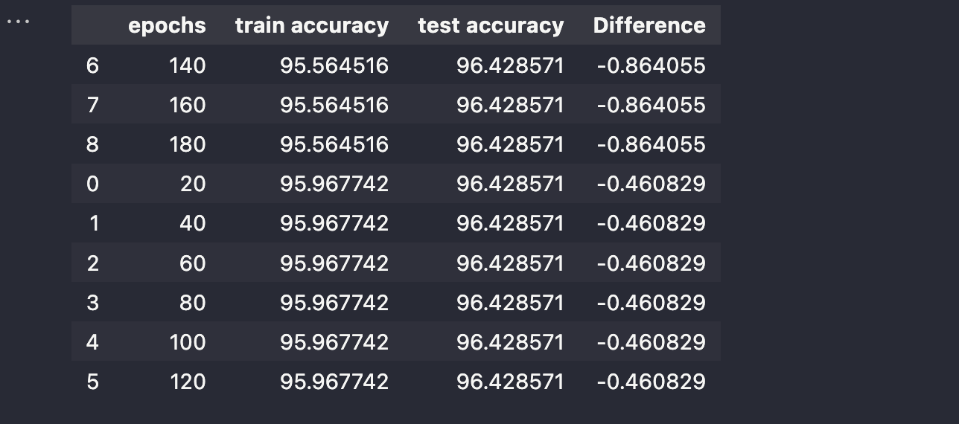

**B.3 Observations and learning:**

* Optimal performance was observed in the model trained for 40 epochs during testing.
* Constraints in adjusting hyperparameters arose due to the Perceptron being coded from scratch.
* The model trained for 80 epochs was excluded from consideration due to its lower test accuracy compared to its training accuracy, a scenario not aligned with ideal model behavior.

**B.4 Conclusion:**

The process of implementing the Perceptron for Cirrhosis Patient Survival Prediction deepened my understanding of its workings and their application in real-world scenarios. This successful optimization underscores the potential of tailored models in addressing specific medical predictive tasks with improved accuracy and reliability . Moreover, noteworthy improvements were achieved in Dataset 2, further affirming the efficacy of the optimized Perceptron model in diverse dataset scenarios.

************************